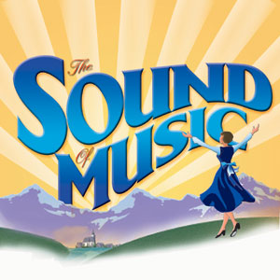
GETTING TO KNOW…
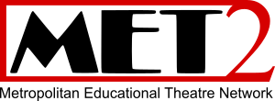

invites you to
follow your dreams and
be part of the cast!
The hills are alive with one of the most loved musicals of all time!

Join Maria as she teaches Captain Von Trapp's children to discover the joys of singing and childhood. Watch as she wins the heart of the Captain. Listen to the unforgettable score of this classic musical with songs like “My Favorite Things,” “Climb Ev’ry Mountain,” “Do-Re-Mi,” and many more. Ages kindergarten and up will surely find some of their own “favorite things” in this delightful family musical.

Workshop begin late August, 2018
It’s not to late to join!

FOR INFORMATION PLEASE CALL: 1-800-961-0194 ext. #2

If you are unable to attend,
please call for late sign-up information.

No experience necessary!

Our workshop fees include weekly rehearsals and conclude with a full week of rehearsals and performances. Everyone who completes our educational workshops will perform on stage in a professional style theatre with costumes, scenery, and live musicians in October of 2018.

Bring two new friends who register and your registration is FREE. Ask about our family discounts and payment plans.

We gladly accept all major credit cards.

Limited Scholarships Available
Workshop Training Fee Applicable

(Workshop fee is non-refundable and does not include costume fee and nominal administrative fee.)

Metropolitan Educational Theatre Network is a non-profit educational organization, which provides a unique opportunity to be active participants in the dramatic process as actors, singers and dancers. Everyone who registers and completes our workshop training is assured a role on stage in our production in Fall of 2018. Renowned educator and theatre director for over 25 years, Alex H. Urban has designed a program that is based on building self-confidence, self-esteem, grace and poise within the individual.

“Follow us and discover where imagination leads!” – Alex H. Urban, Founder

MET2 is the true educational theatre company designed and directed by educators.

Check Us Out at www.MET2.org or email us at MET2america@aol.com

Limited Scholarships Available
A Non-Profit Organization
#33-0794860
It is important now more than ever that we find quality programs that will engage our young people in the creative process.

